Agentic AI
https://learn.deeplearning.ai/courses/agentic-ai/lesson/nae3i1/what-is-agentic-ai%3F
Table of Contents
Module 1: Introduction to Agentic Workflows 1
Definition of agentic AI workflows: 1
Degrees of autonomy: 2
Benefits of agentic workflow: 2
Agentic AI Applications: 2
Task decomposition: 3
Evaluating agentic AI (evals): 5
Agentic Design Patterns: 5
Module 2: Reflection Design Pattern 7
Reflection to improve outputs of a task 7
Evaluating the impact of reflection 9

Module 1: Introduction to Agentic Workflows

Definition of agentic AI workflows:
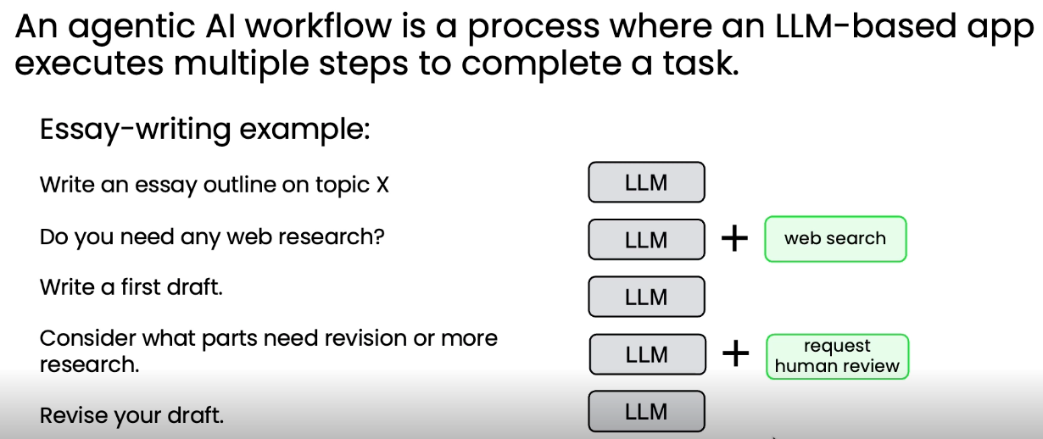

Degrees of autonomy:
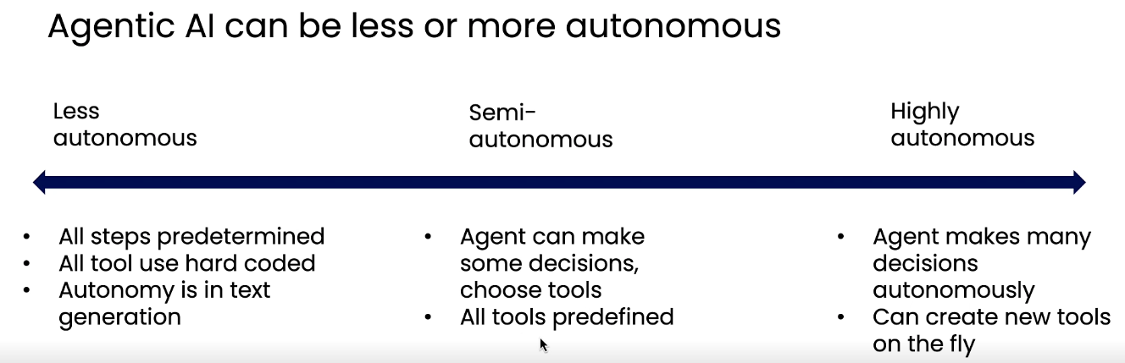

Benefits of agentic workflow:
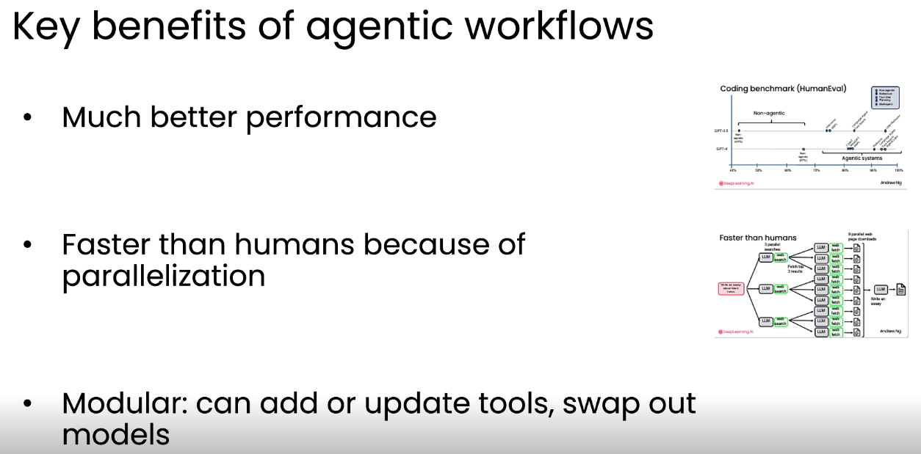
Note that, better performance is because agentic workflows enable iterative improvement through reflection and revision, often delivering gains larger than upgrading to newer model generations.

Agentic AI Applications:
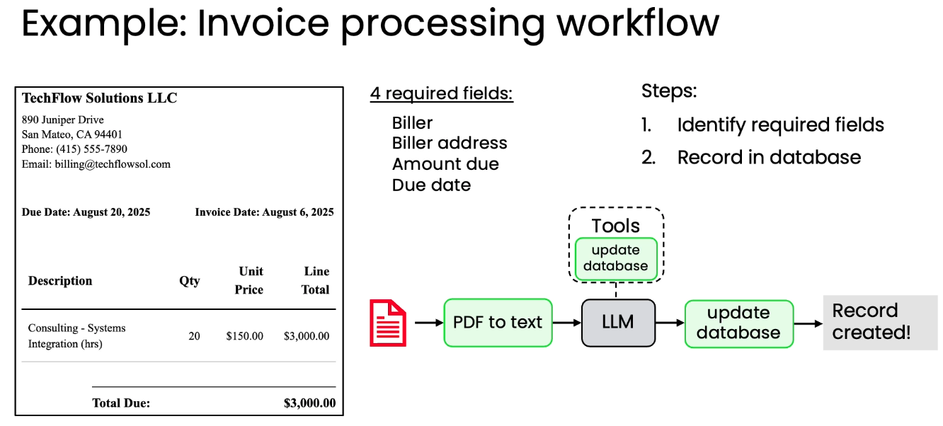
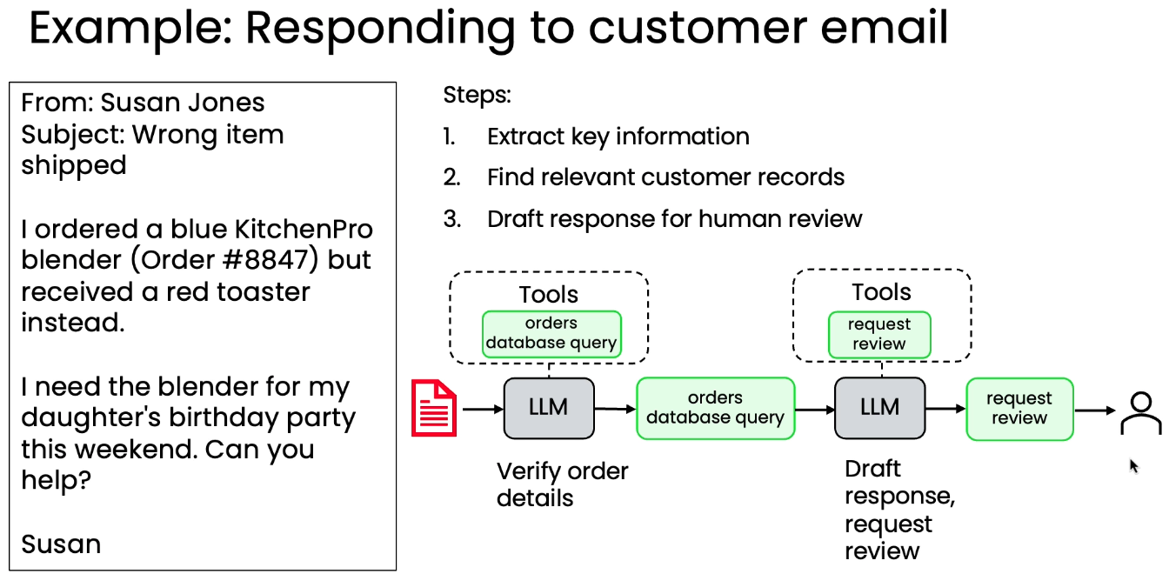
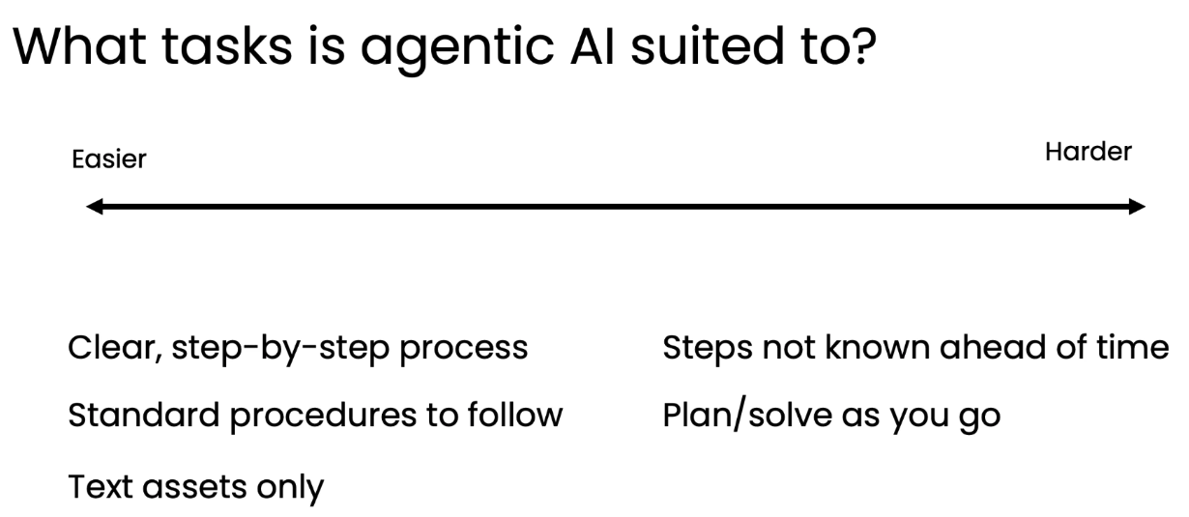

Task decomposition:
Q: When decomposing a complex task into steps for an agentic workflow, what is the key question to ask about each individual step?
A: Whether the step can be implemented using either an LLM or available tools like APIs and function calls.
Example 1: decomposition on essay writing (3 ways)

Example 2: decomposition to respond to customer email
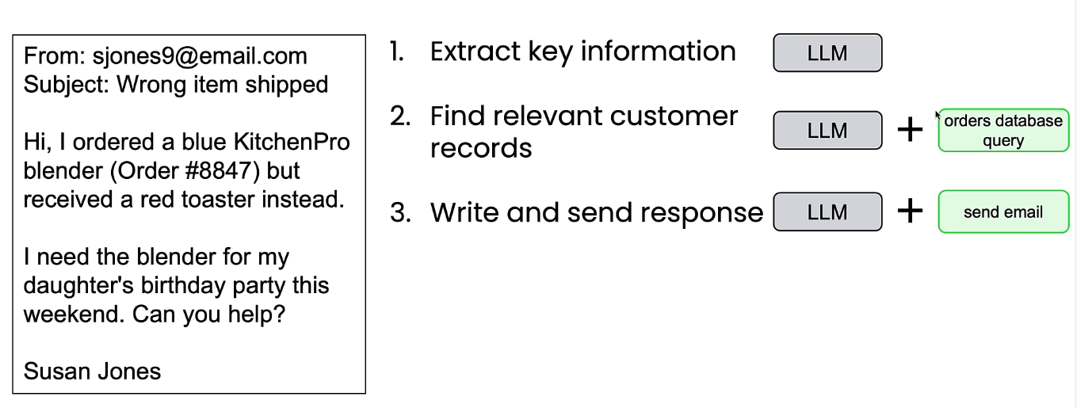
Building blocks:
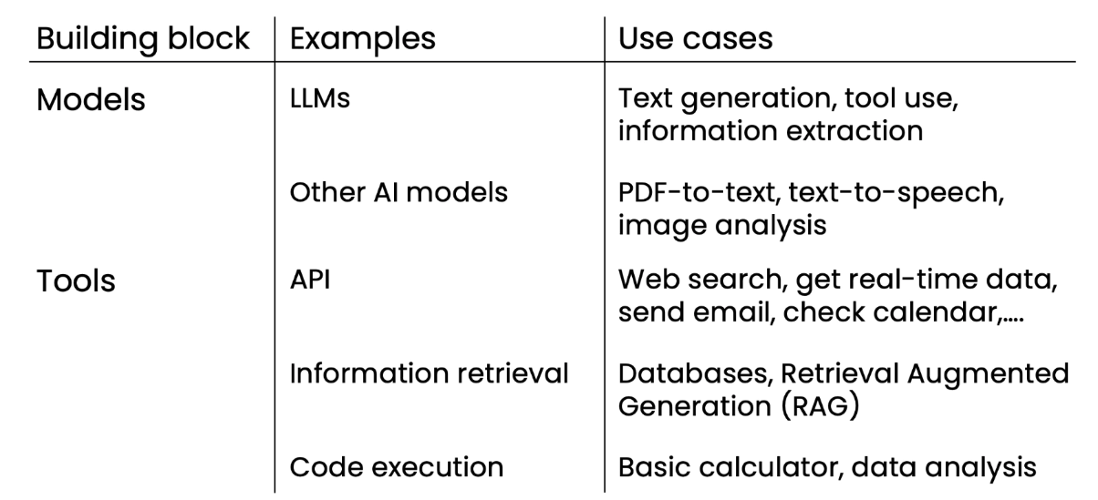

Evaluating agentic AI (evals):
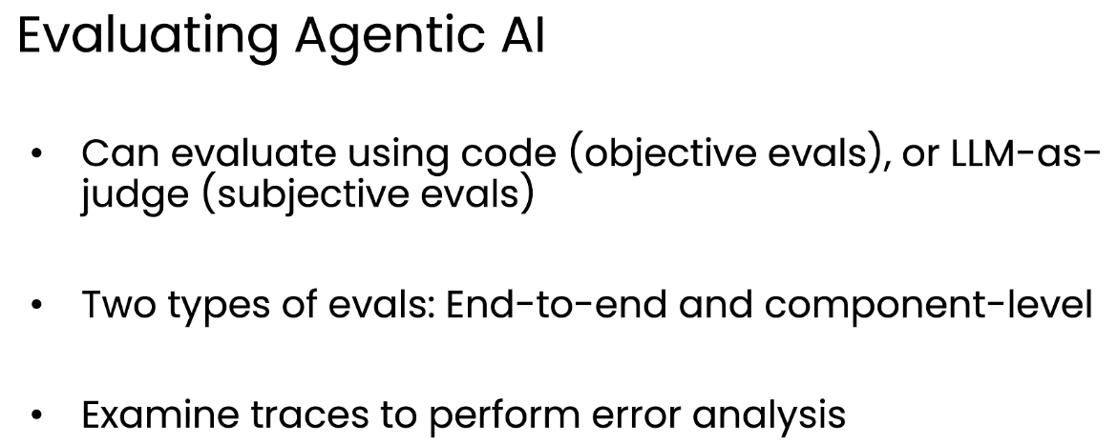

Agentic Design Patterns:
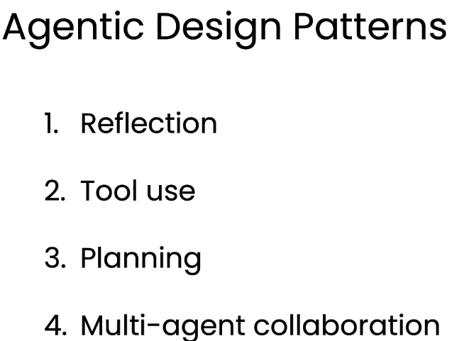
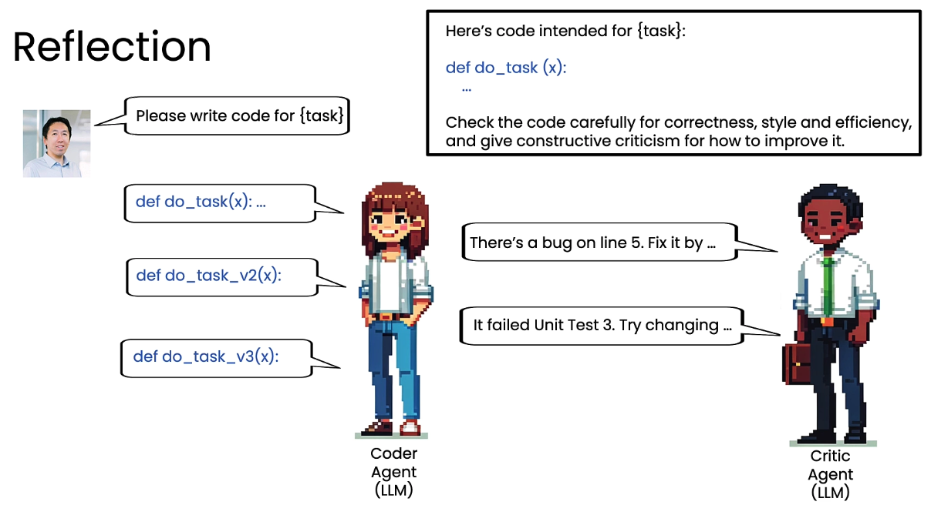
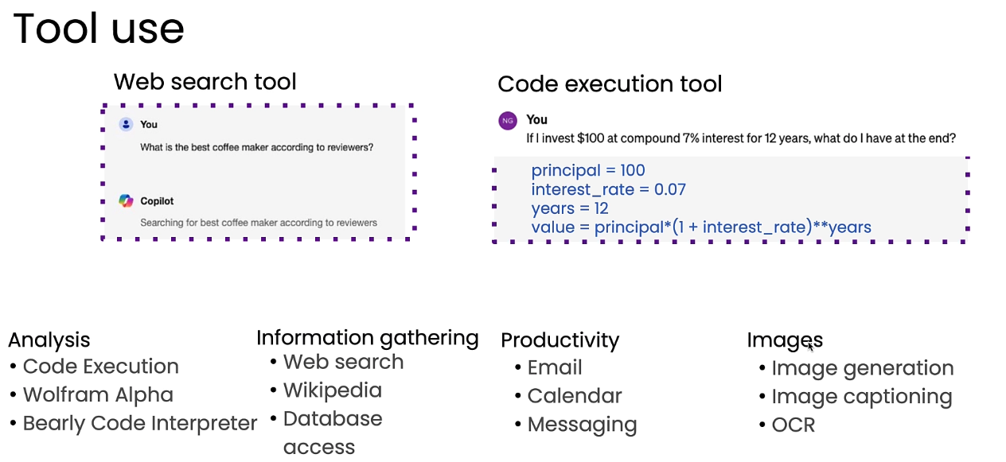

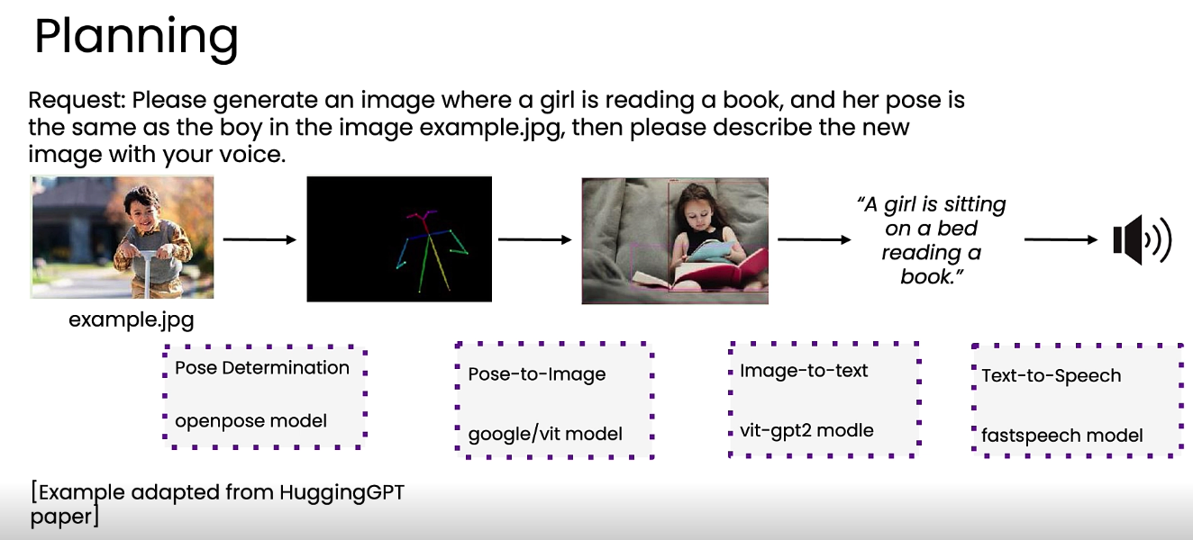
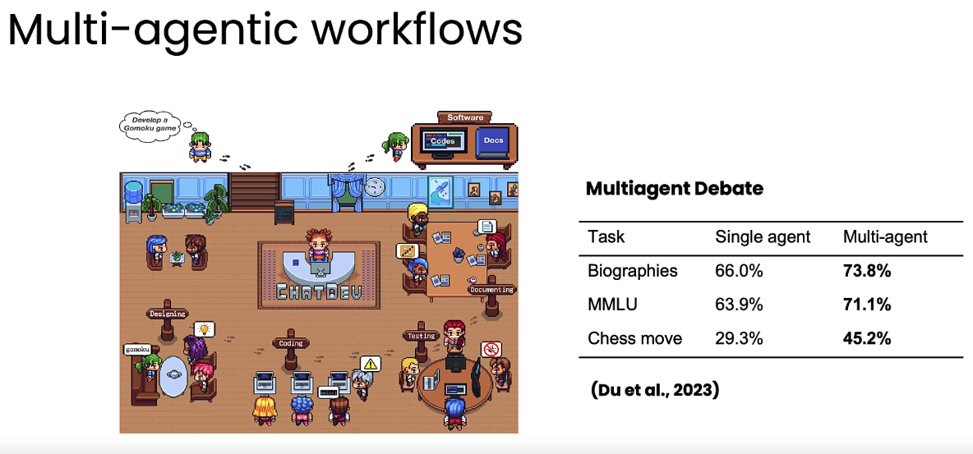

Module 2: Reflection Design Pattern

Reflection to improve outputs of a task
Core mechanism of the reflection design pattern: An LLM examines and critiques its own output, then generates improved versions, similar to how humans edit their work.
1. Typical workflow to use reflection:
e.g. reflection to improve code (reasoning/thinking models are good at checking/reflecting)
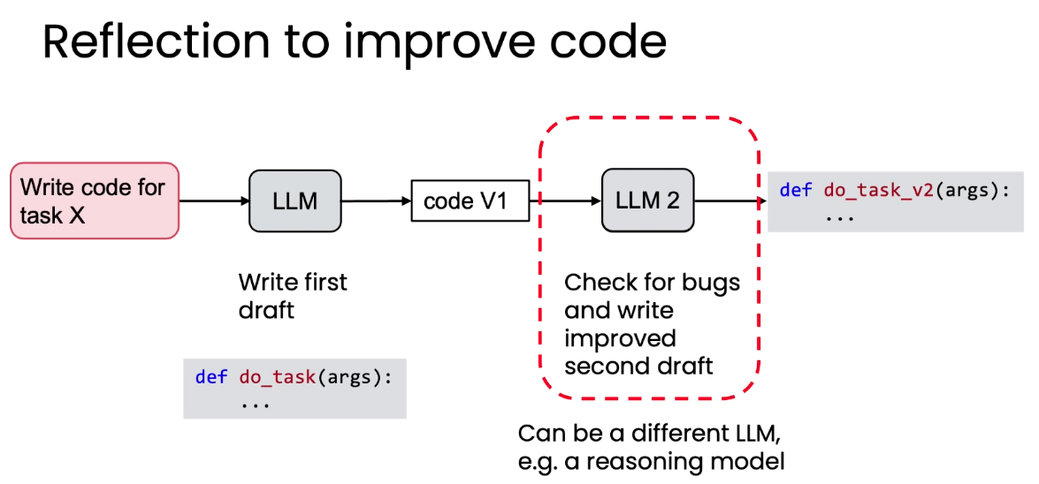
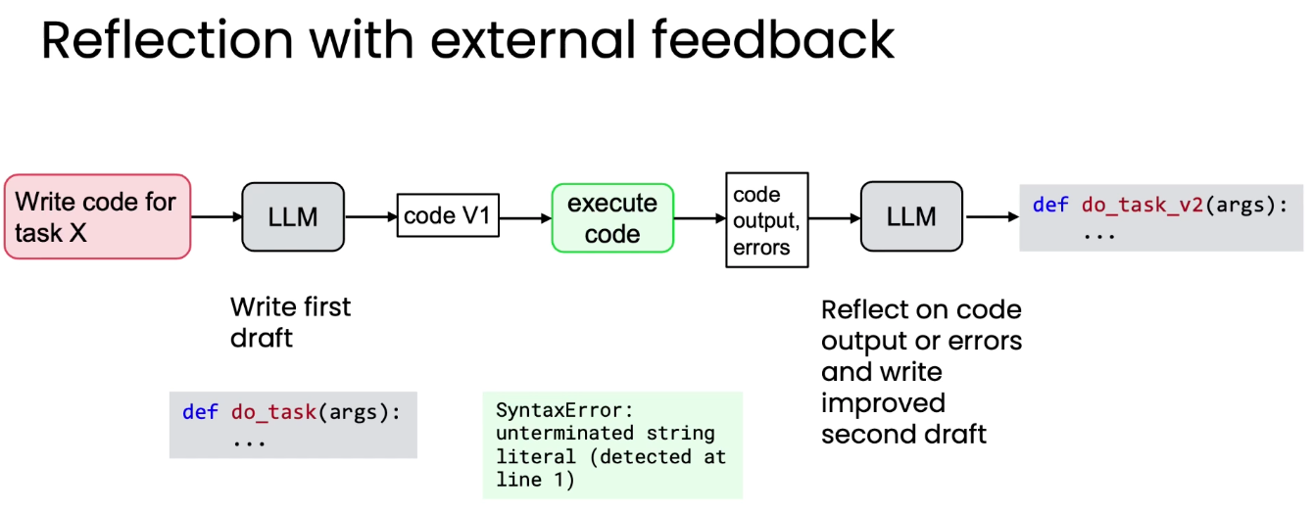
2. Tips for writing reflection prompts:
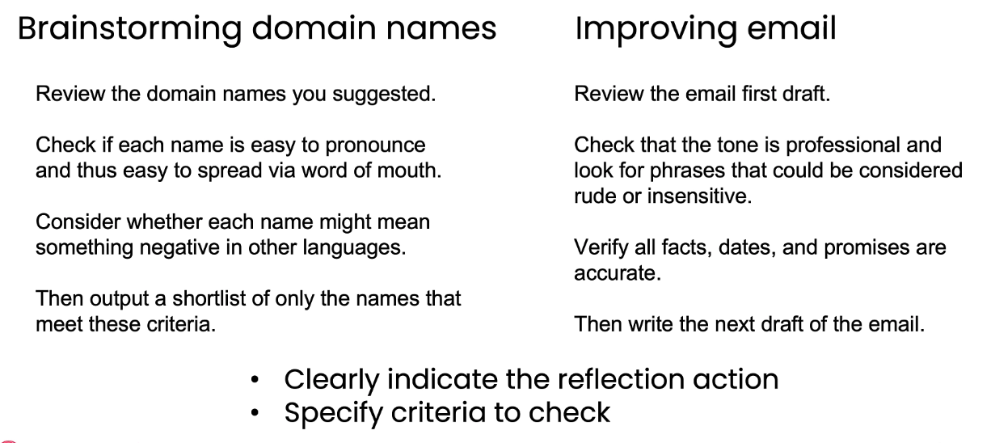

3. Reasoning models may work better for reflection:
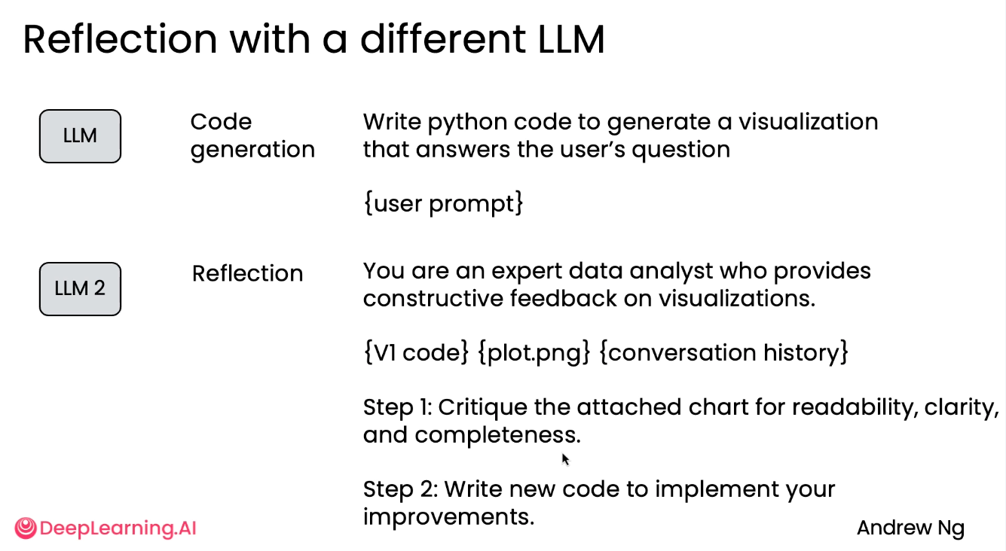
4. incorporating external feedback into the reflection process often lead to greater improvements in LLM-generated outputs compared to relying only on internal reflection because external feedback provides new information, enabling LLMs to identify and correct issues they cannot detect internally. Example:
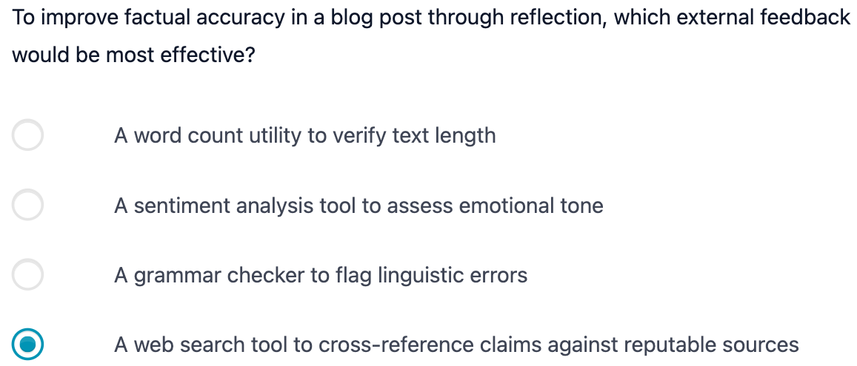

Evaluating the impact of reflection
Adding reflection to the workflow slows down the process. So we need to evaluate whether it is worth it. Here is the summary: 1) for objective evals: code-based evals are easier, and we can a build a dataset of ground truth examples; 2) for subjective evals: we can use LLM as a judge with rubric based grading (Use a rubric with specific binary criteria to evaluate individual outputs, then sum the scores). Two detailed examples are shown below.
- Example of objective evals: change the reflection prompts and check the correctness with and without reflection
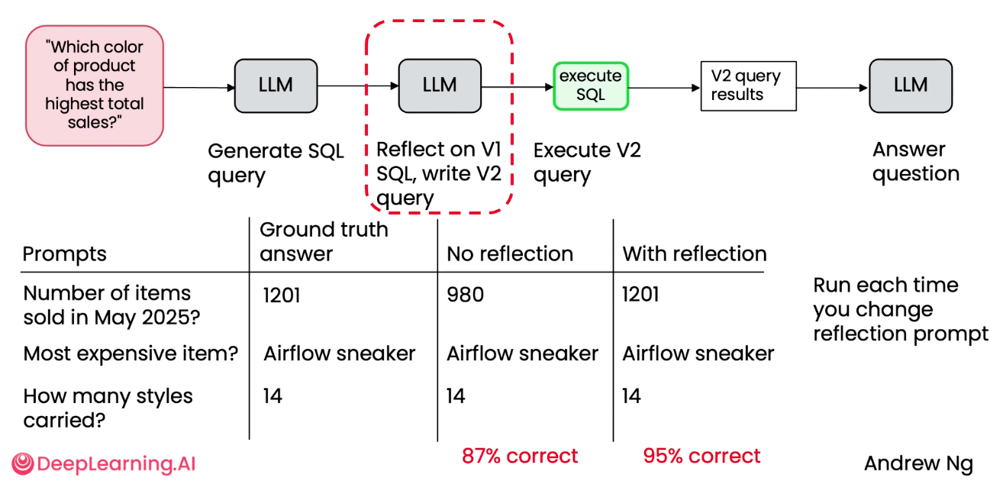
- Example of subjective evals: how to we evaluate qualitative result? Answer is to use LLM-as-a-judge. However, the known issues with using LLMs is 1) answers often not good, and 2) position bias. To solve this issue, we can grade with a rubric to get more consistent results.
